Journey to your first bug
By Imad Husanovic (deadoverflow)

Small intro

Hunting for bugs can be challenging at times, especially when you are just starting out. To be honest with you, when I was starting out, for a couple of months I just couldn’t find anything. And it was really frustrating but as time went on, I developed some techniques that I use even today in order to catch a vulnerability every week! This mini book will try and teach you how to use the knowledge you have about vulnerabilities to actually find a one. I will be explaining how I approach websites to look for vulnerabilities and methods that I use found me a lot of different vulnerabilities in the past 2 years that I have been active in field of cyber security research.
Firstly, I advise, if you are not familiar with the following vulnerabilities: CSRF, XSS, Clickjacking, IDOR, WebSocket, you firstly get familiar with them (On Portswigger for example) and then come back to this book. Also, I will be using Chrome developer tools (F12) and Burp Suite (Community or Professional). Just make sure you have Burp installed and you are good to go!

As we dive into the world of bug hunting, let's not delay any further. Let me share insights, strategies, and lessons learned to empower you on your bug hunting journey!

deadoverflow
CSRF – Cross Site Request Forgery
I will do a brief explanation of every vulnerability just to remind you in case you don’t have a clear vision or you just forgot.
Cross-Site Request Forgery (CSRF) is a type of security vulnerability that occurs when an attacker tricks a user's browser into making an unintended and unauthorized request. This usually happens when a user is authenticated on a website, and the attacker can exploit this trust to perform actions on behalf of the user without their consent.
The way I exploit CSRF is really simple and I love to hunt for these vulnerabilities because it is really easy and almost every time, my method, yields me a vulnerability.
So, you have found your target, in my case, my target will be some random website.
Firstly, when you are on your target website, you should open up Chrome developer tools by pressing F12 or Right-click and click Inspect or CTRL+Shift+i.
After you have opened the developer tools, navigate over to Network tab. This tab is responsible for any HTTP requests that are being made on your target website.
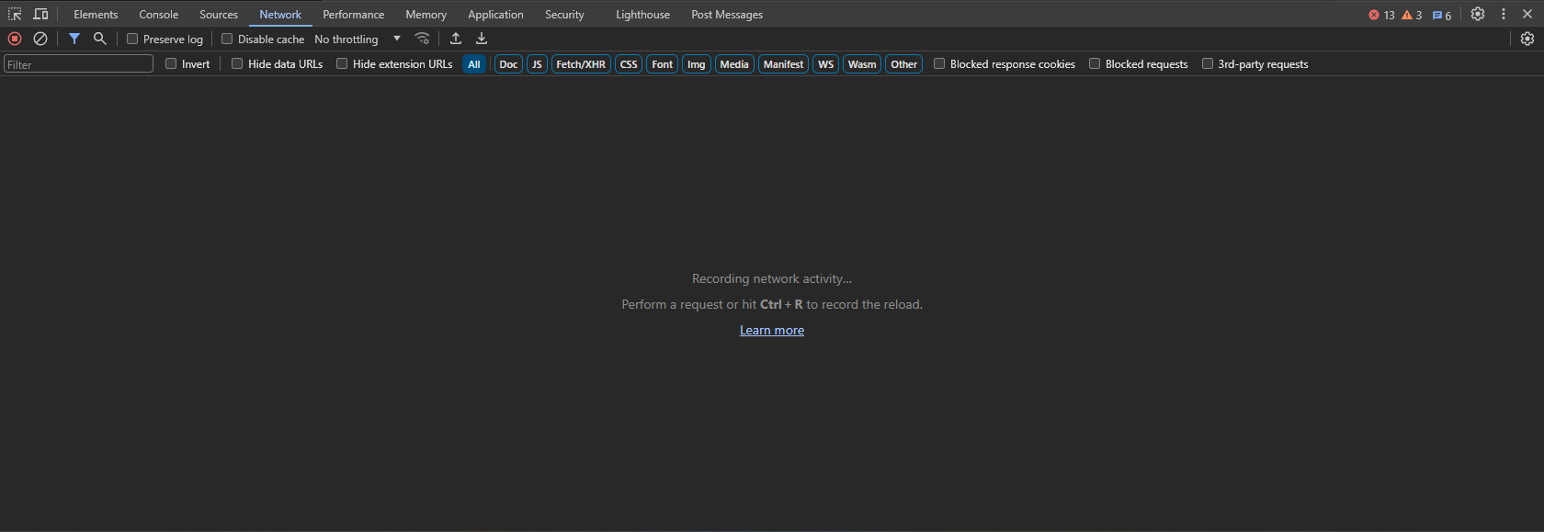
Then just start playing around with the website. This website is a chat based website so lets try to send a message. When I try to delete a message, this request has been made to the target website’s API.
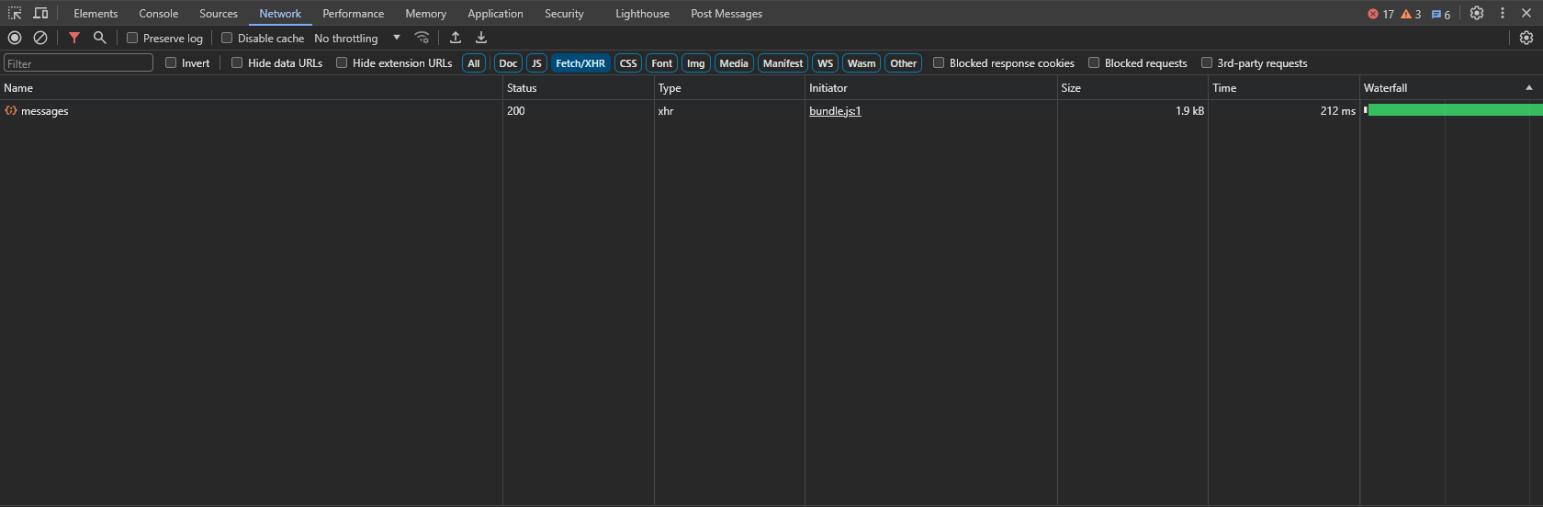
If you click on the request you can see what has happened.
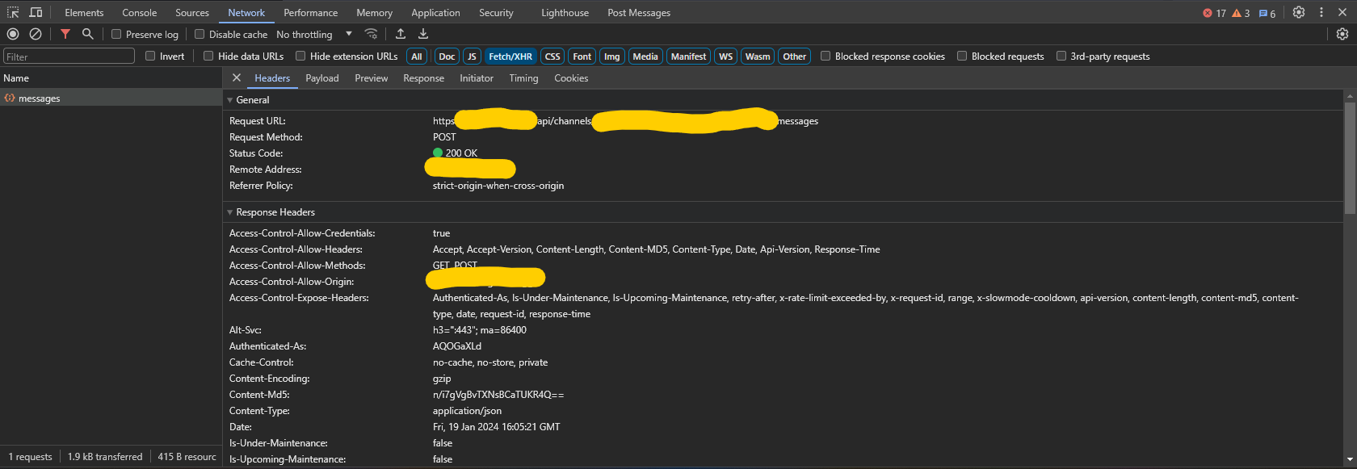
I blurred out the domain just to protect the identity of a website.
Now you can test to see if you can send messages on behalf of other users via CSRF vulnerability. Right click on the request, click Copy and then click Copy as fetch.
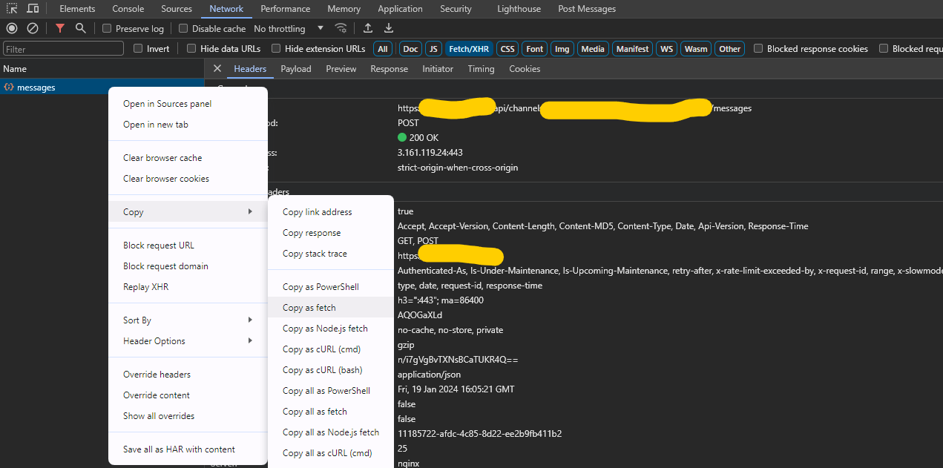
Now lets test to see if there is a CSRF vulnerability.
Go to another website, I recommend you go to example.com and open again developer tools but this time navigate over to the console tab.
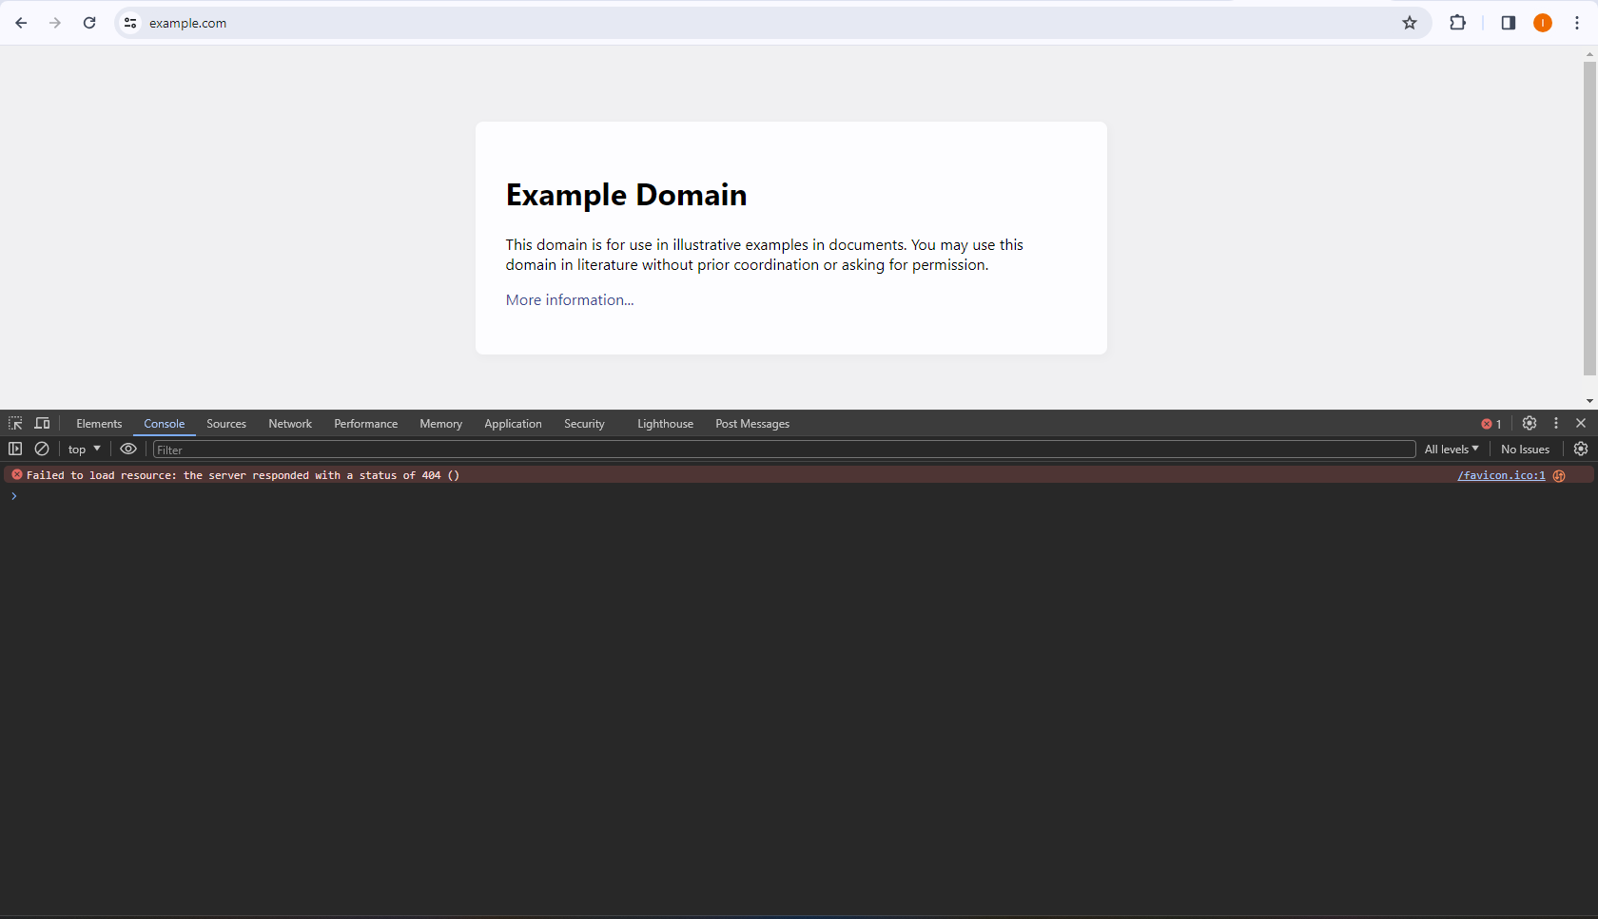
Now I will paste what I have copied earlier in the console.
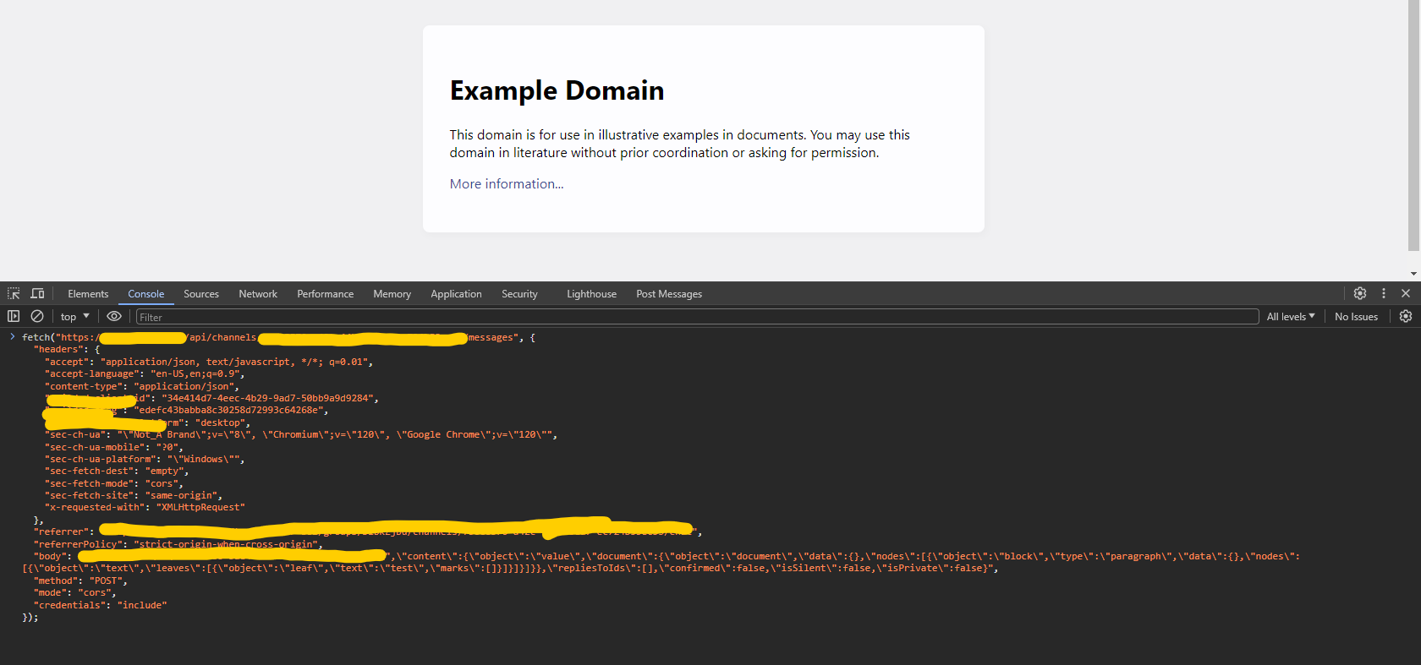
However, you might see mode property here. Make sure the mode property is set to no-cors.
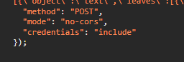
Now just hit enter and see what happens.
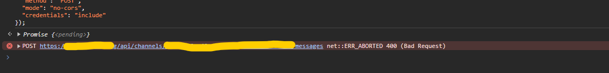
As you can see, this request has failed, meaning this website has proper protection against requests that are sent from another domain, in my case from example.com.
So what now? I didn’t find a CSRF and should I stop looking for them. I mean this website probably has protected every API endpoint, right? No! Always test for more. I will now see if I can add a message reaction like a smiley face or sad face from another domain. Lets test that out!
So I will make a message reaction on this website and there is a HTTP request made.
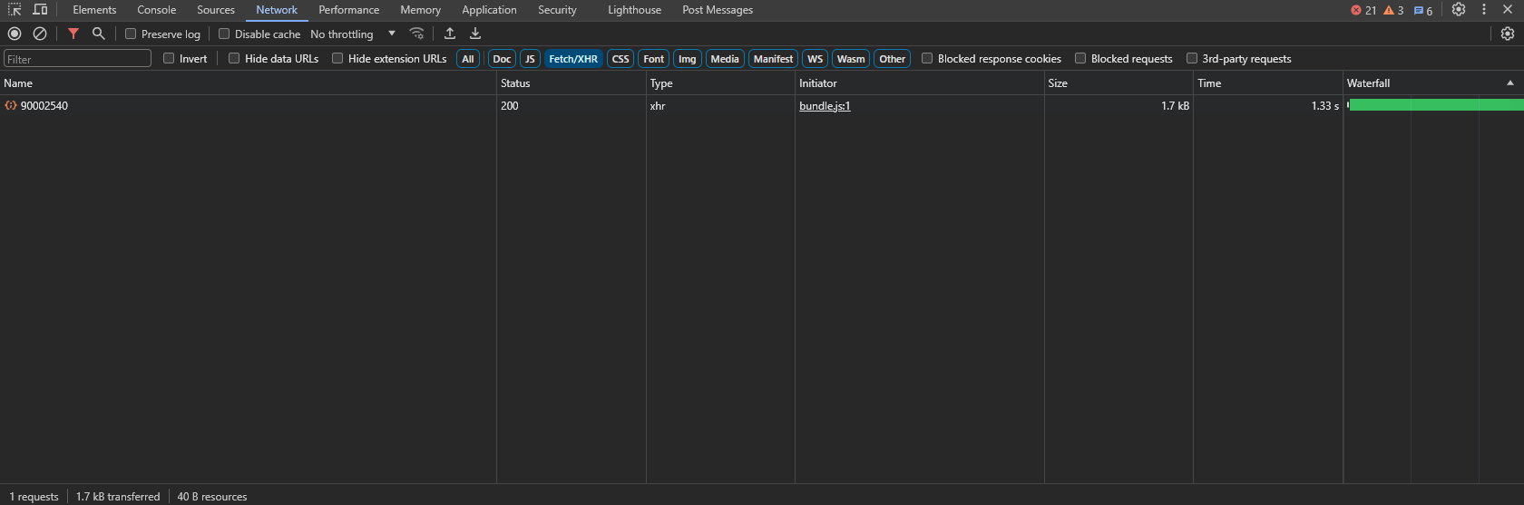
I will again click Copy and Copy as fetch, go to example.com, set mode to no-cors and try sending the request.
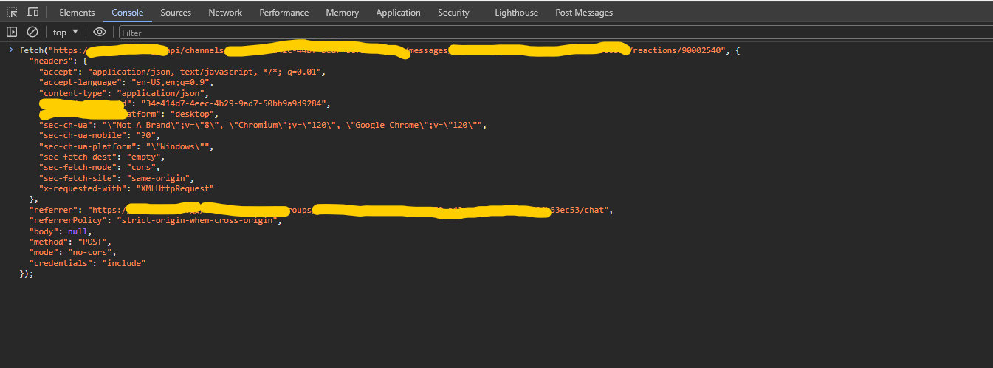
Now I will hit enter to send this request from example.com.
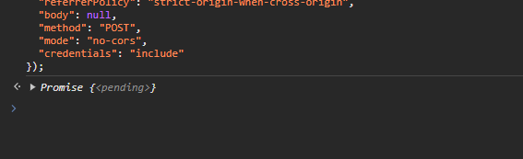
Notice how there is no error showing up. Let me switch to the network tab to see if the request received a 200 Status code.
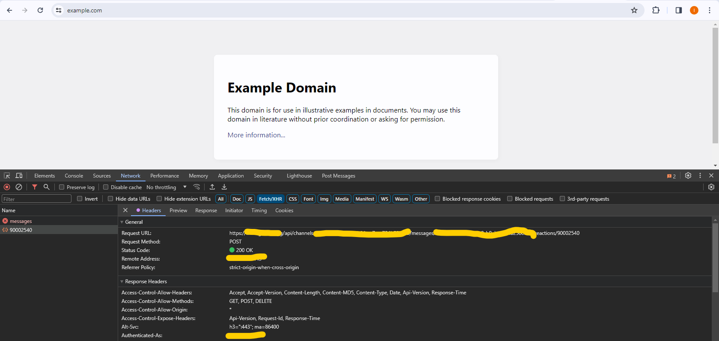
As you can see, this request was authorized and now let me check if I added a reaction to a target message.
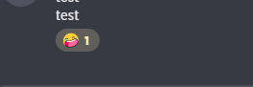
And sure enough, I did!
This is a CSRF vulnerability where an attacker can create an exploit website which once the victim visits, it will automatically send a message reaction request to a certain message and add a reaction on victim’s behalf to that message if the victim is logged in.
The console tab executes code as if it was executed on a page where the developer tools are opened. So, this just means the example.com sent an authorized and authenticated request to add a reaction to a whole different website and it worked. You can now try different things for example updating profile information then see which request did that in the network tab, copy it, go to example.com, open console and paste the request, change the mode to no-cors and try sending it from example.com. If it works, then you found a vulnerability, if it doesn’t then look for something else, just like I did.
I did report the vulnerability but it got closed as informational since it isn’t a high priority bug however, using this technique, I found another CSRF on this website which was far more serious than this one. That vulnerability is currently being fixed.
Hopefully this briefly summarizes how I hunt for CSRF vulnerabilities and hopefully you will learn something from this. If you have any questions, you can reach out to me via email ihusanovic3@gmail.com or on Instagram @deadoverflow https://instagram.com/deadoverflow
I will be answering any questions you may have!

Let’s now move onto XSS!

XSS - (Cross Site Request)
This is another vulnerability that I struggled to find even after finding my first few bugs. It was just not happening. I really tried hard to find it and then I developed a really good strategy on finding XSS.
Be aware that websites sometimes implement a really good protection against XSS and it could be difficult to find it. Just look for it everywhere.
Again, I will be showing this on an actual target and showcasing and actual vulnerability I found and reported.
XSS is a little bit trickier to find however, I still am relying on Chrome Developer Tools.
As for any other bug, you have to rely on your logic mostly because you will experience a lot of different websites that could be exploitable. My advice, or how I approach this, is by pasting this <>/’”<img> in input fields or somewhere where I want to test just to see how the website would respond.
So I will try and enter this in a password field for my router.
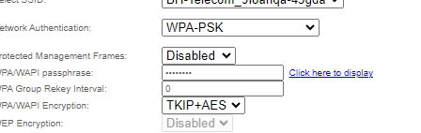
Button “Click here to display” is responsible for displaying the currently entered password.
Let me paste now what I usually do in this input field.
After I pasted it, I will click the button to display the password and monitor what is happening.
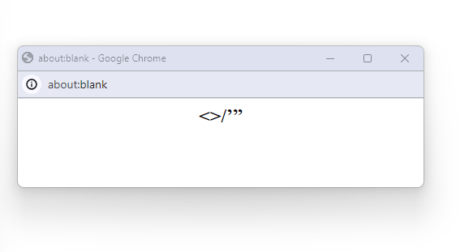
It opens a new window and in there it displays the password. However I entered this <>/’”<img> and I can see that the <img> is missing. I will open Developer tools on this window to see what happened.
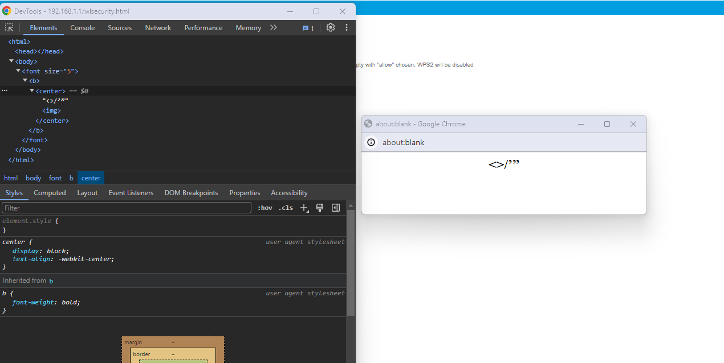
As you can see in the elements tab, there is the <img> element parsed as HTML. Now I will try my exploit: <img src=x onerror=alert(1)>
Once I paste this in the password field I will press the button again and this happens:
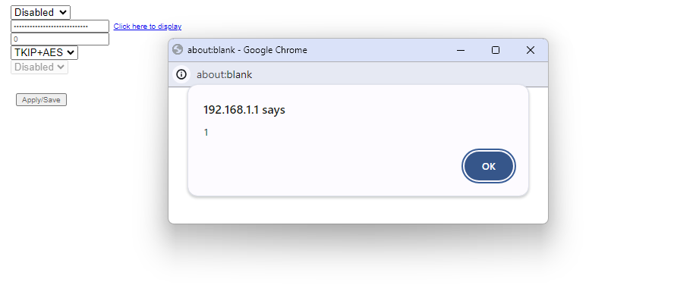
And just like that, there is reflected XSS on this router’s web interface.
However not always It will be this easy, sometimes you need to be creative.
For example, I wrote a write up about this a while ago you can find it here:
As you can see in the image below, the router’s web interface was encoding this symbol ‘ so it prevents attackers from executing code on 192.168.1.1 by just setting a wifi name to be something malicious.
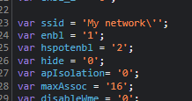
But even tho this symbol ‘ was encoded, <> these weren’t.
So I changed the name of the wifi to: </script><script>alert(1);//
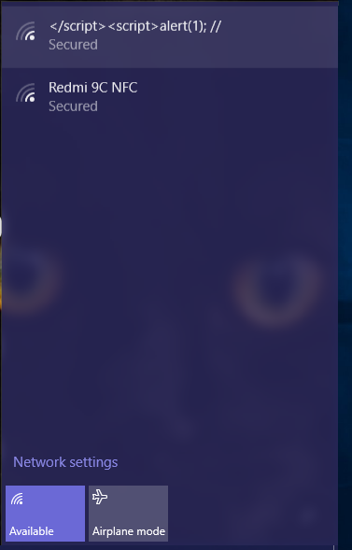
After I connected to my network and visited the router’s web interface I was greeted with this:
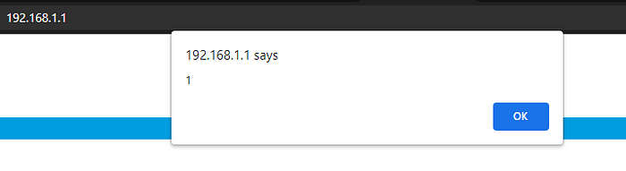
To actually see what happened, here is the source code of the page:
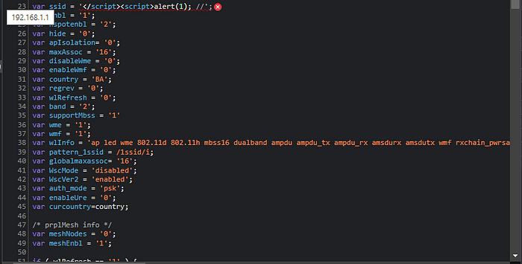
My exploit closed the existing script tag, and opened a new one with my attack payload. This technique I learned from Portswigger so I highly recommend you check them out.

Clickjacking - (UI Redressing)

Clickjacking is a type of vulnerability that is really easy to hunt for. I would argue that it is the easiest vulnerability to hunt for but among harder ones when it comes to developing an exploit.
Usually, I use AI like Chat GPT to develop an exploit since it is the easiest way, I just need to patch a few things here and there in the code and it’s all good to go! Note that you need to know basic HTML and CSS as well as some basic JavaScript.
With that said, let’s just start!

Every HTTP request contains headers to help the web server know who is currently requesting some resource. For example, when you visit https://example.com your browser sends an HTTP request containing HTTP headers like this:
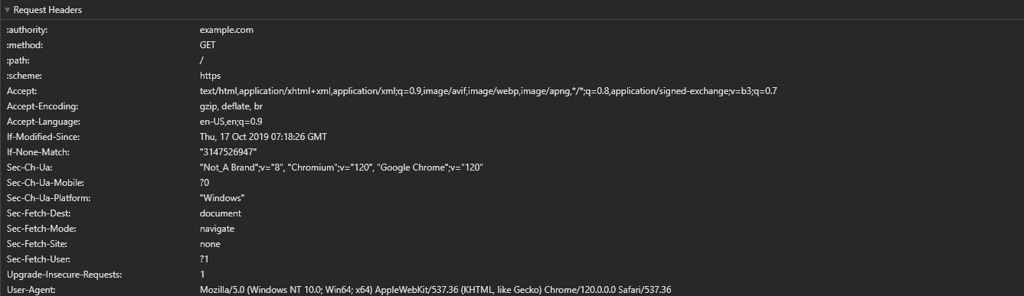
Once the server returns a response, the web server also returns response HTTP headers like this:
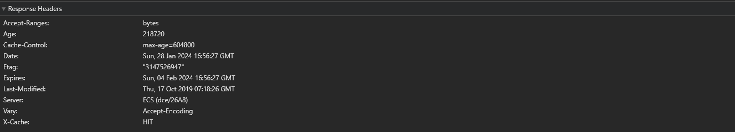
If you are not familiar with request and response HTTP headers, I recommend you check out this and then come back here: https://developer.mozilla.org/en-US/docs/Web/HTTP/Headers
We are going to be mostly talking about X-Frame-Option response header since it is a key factor in identifying a vulnerability.
X-Frame-Options is a security header which tells the browser if it should allow other websites to iframe it or not. For example if you navigate over to Instagram.com you can see that they have an X-Frame-Options header set to DENY, meaning browser would not load instagram.com if it’s embedded in an iframe.
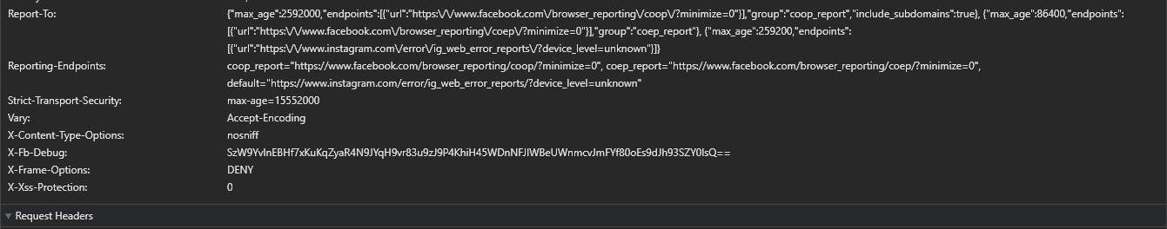
Now that you know what is this header, let’s start researching!
Once you get your target website ready, you want to open chrome developer tools and navigate to the Network tab.
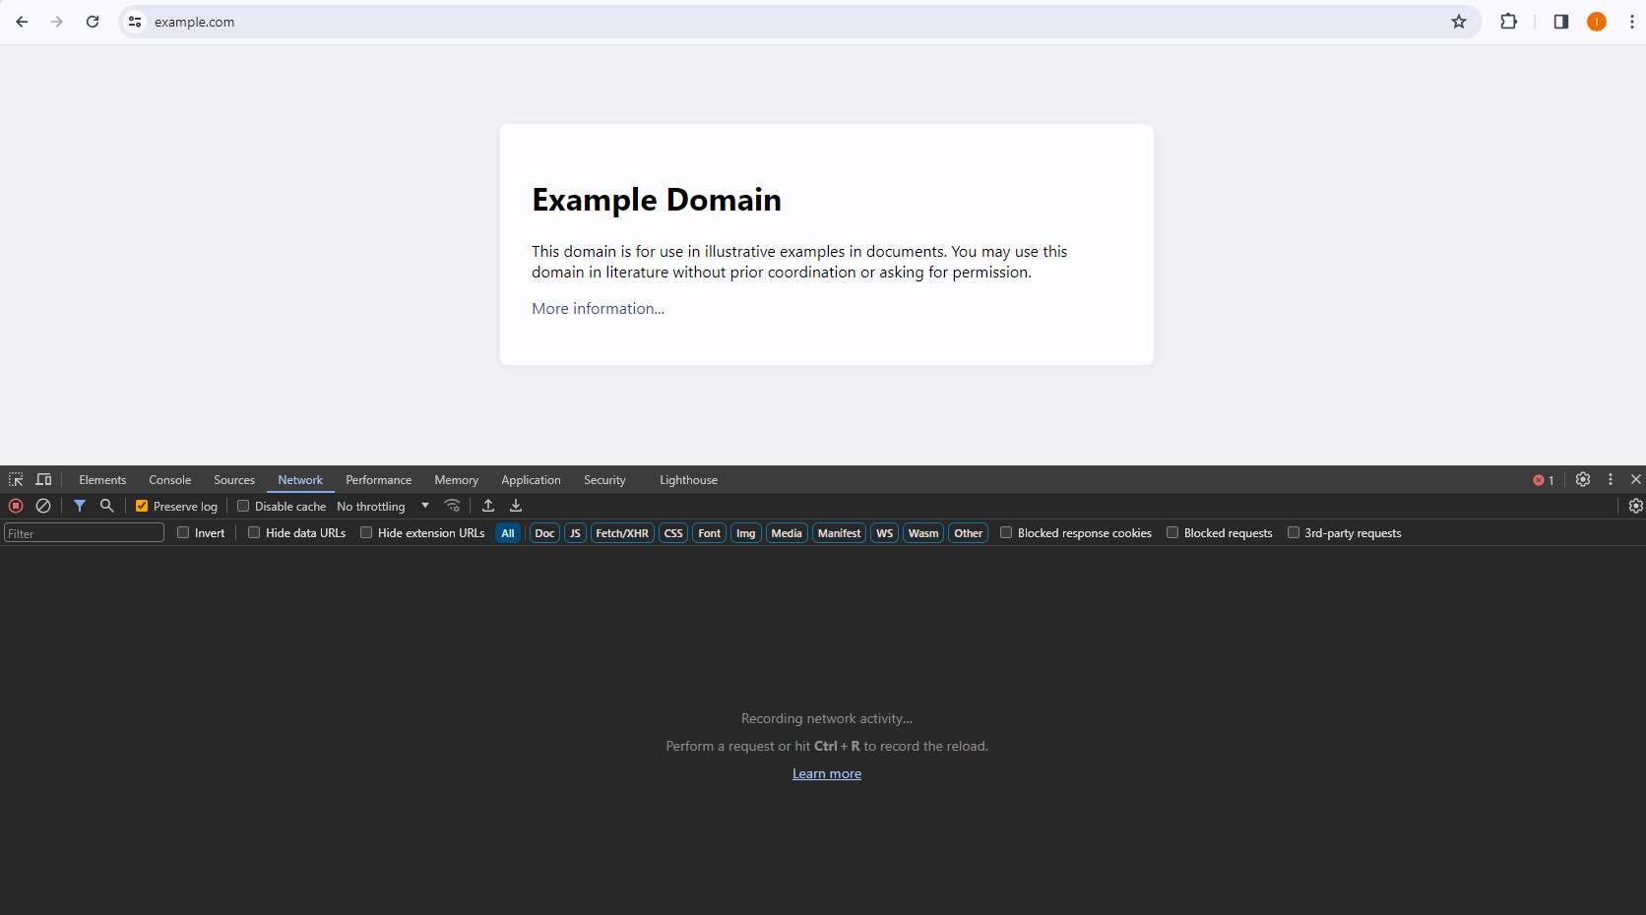
Then let’s navigate to the Doc tab instead of All. 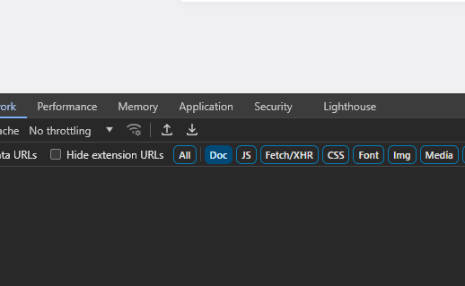

Now let’s refresh the target webpage.
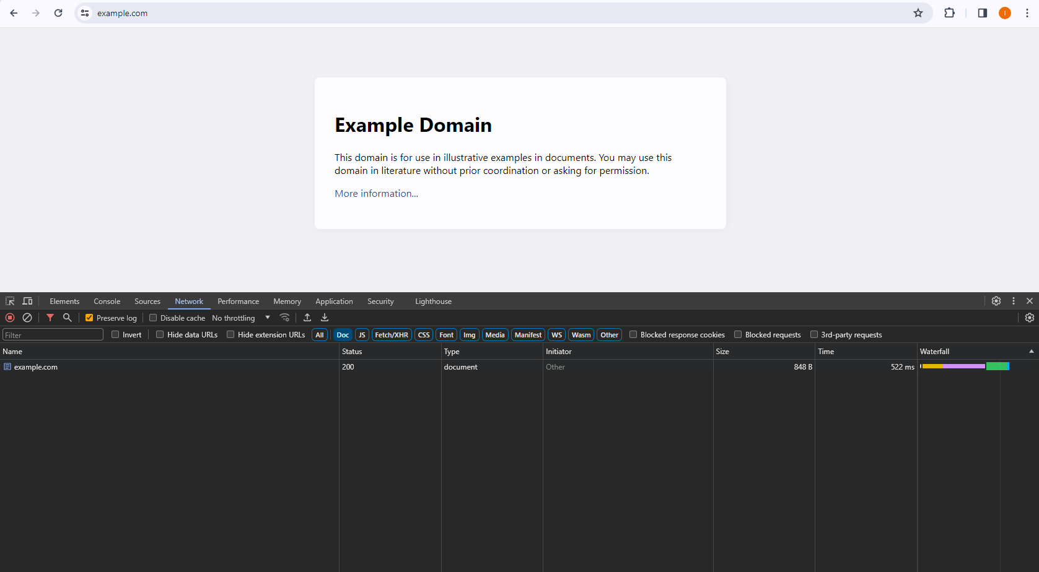
You can see that there is an example.com HTTP request being captured so let’s expand it and see if there is X-Frame-Options header present.
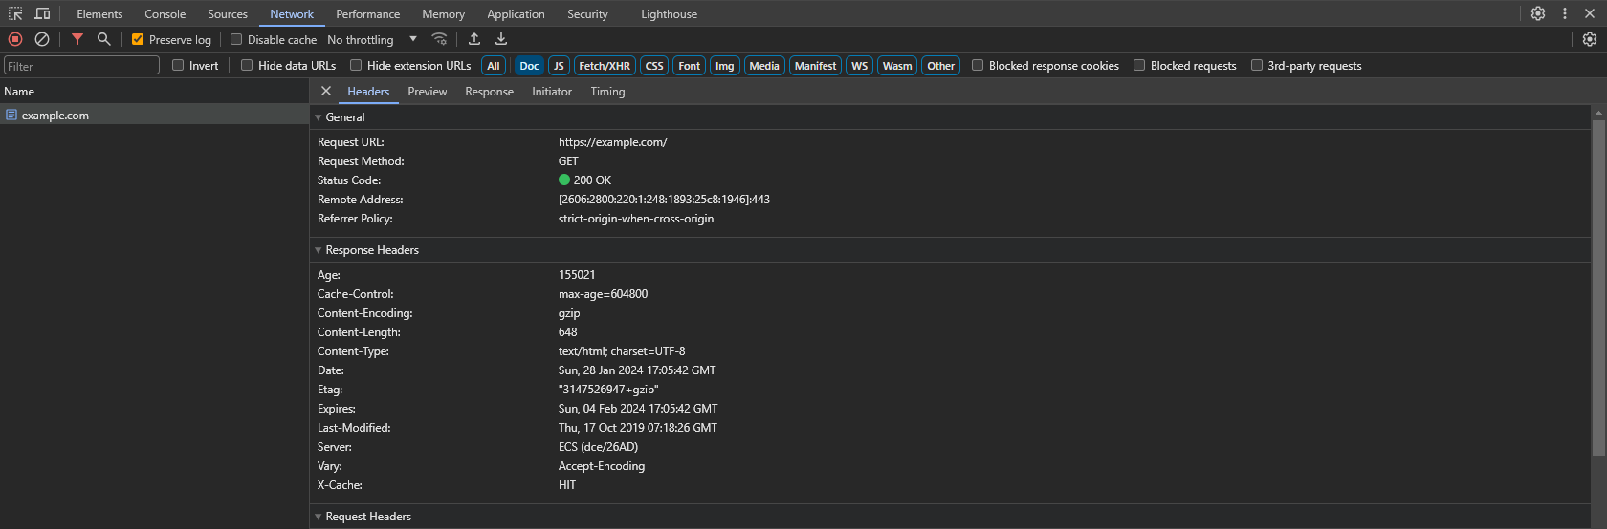

As you can see in the image, there is no X-Frame-Options header present, meaning we can just add example.com into an iframe.
So let’s try that out!
I created a new HTML document and wrote this:
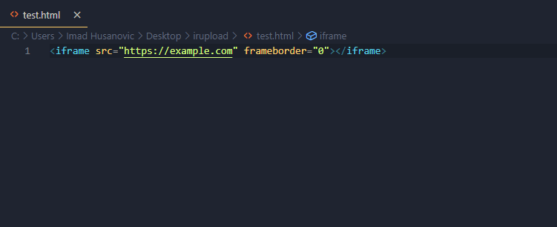
This HTML will try to load example.com and now let’s see if it can successfully load this page.
I will open this test.html document in the browser now.
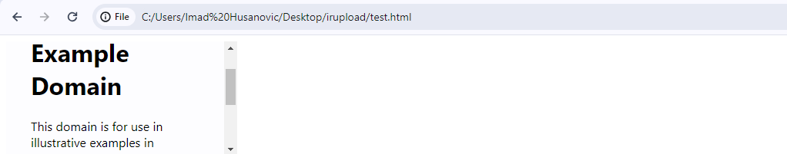
As you can see, example.com can be loaded from any other domain but is this a vulnerability?
The answer is, no. This is not a vulnerability because there cannot be any sensitive actions preformed.
Let’s take a look at another target where there is actually sensitive data stored and available.
That target will be my routers web interface again, so let’s research.
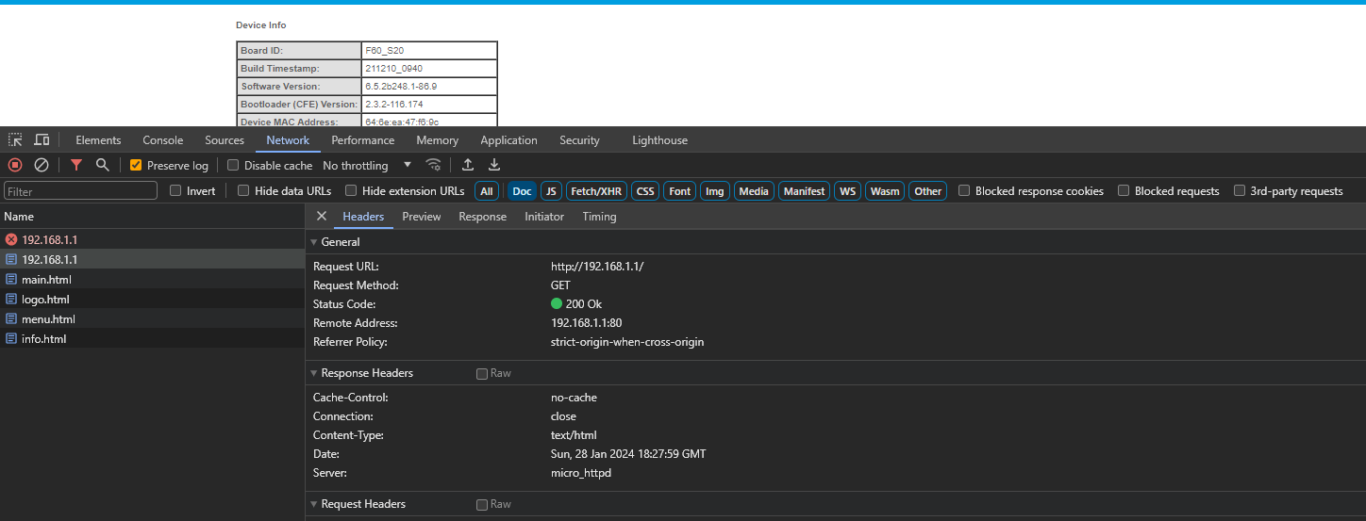
Once I logged in and connected to the web interface, I immediately noticed that there is no X-Frame-Options header present, so let’s try to put http://192.168.1.1 into an iframe.
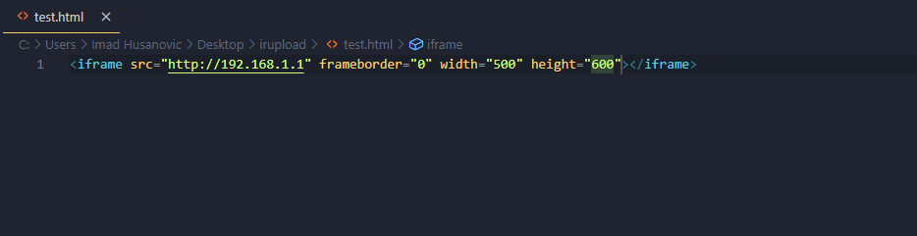
This is the HTML behind this test, now let’s open this document in a browser and see what happens.
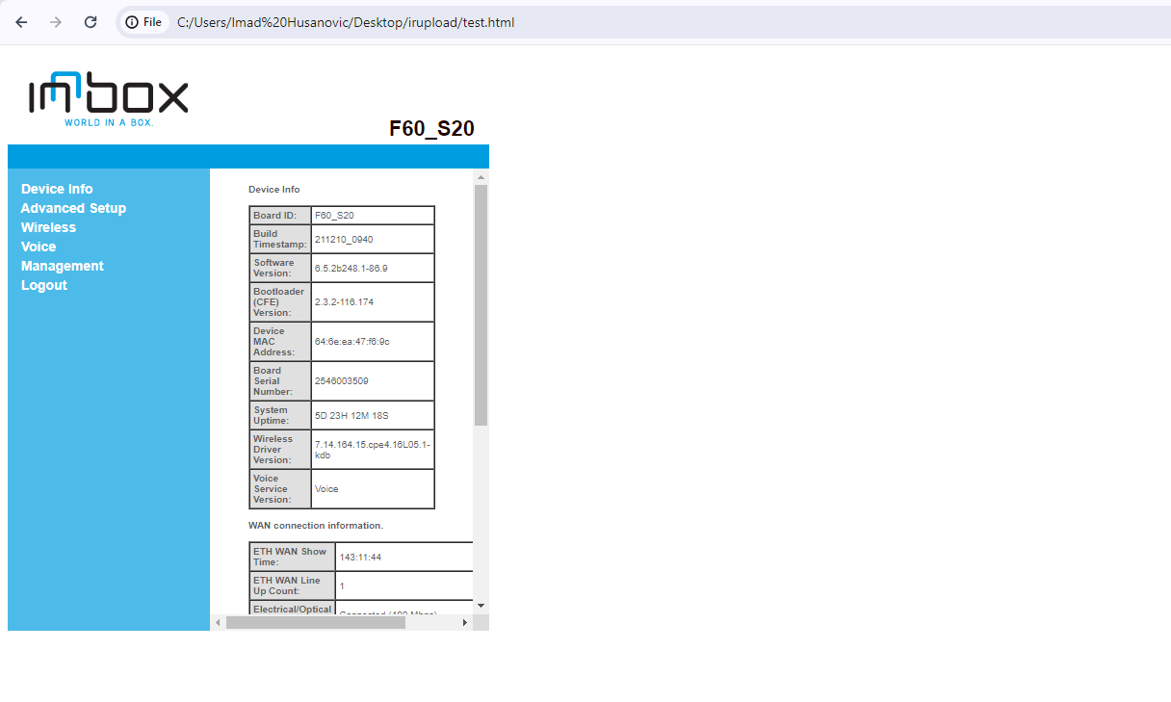
As you can see, this successfully was loaded into a whole different webpage meaning that this could be a vulnerability, however we first of all need to see what could be our attack surface.
I explored the web interface a little and found this:
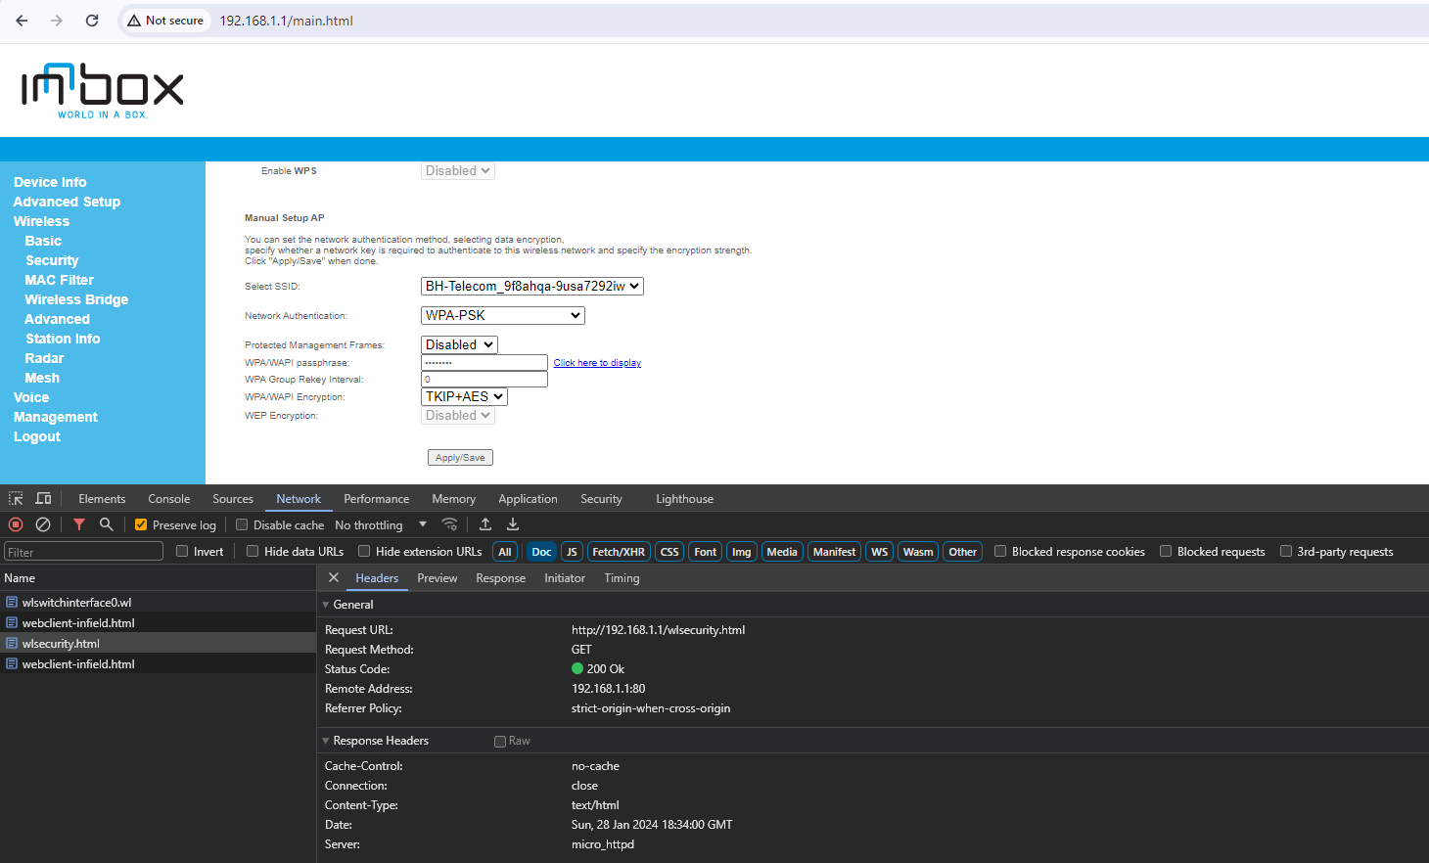
The panel to reset your password is another HTML file and there is also no X-Frame-Options header present on it’s response. Now I will copy this:
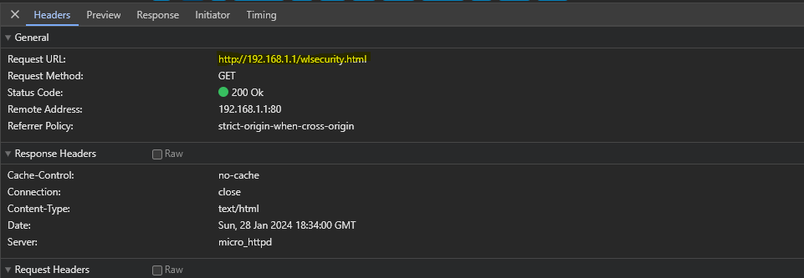
and try to put it into an iframe.
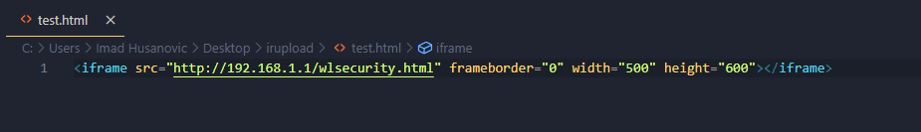
Now lets open test.html in browser and see what happens.
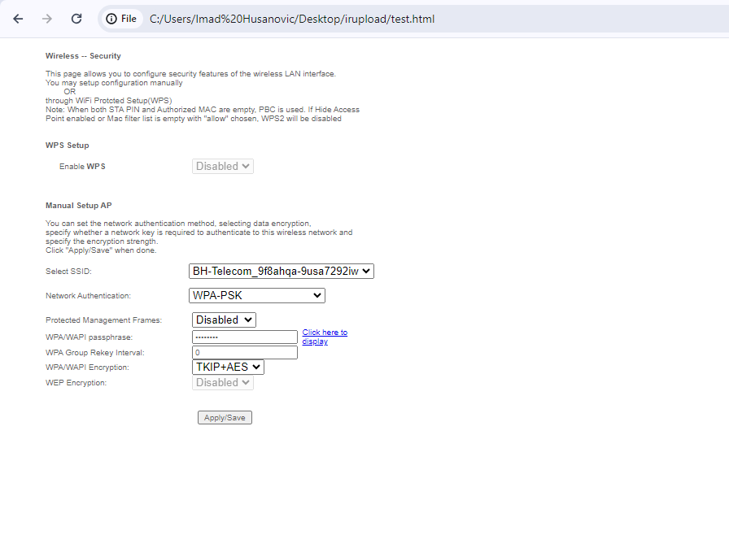
As you can see, this was also loaded successfully and this is in fact a vulnerability.
An attacker can now mask some stuff and trick the victim into setting a password that an attacker wants.
The way you would trick the victim into doing something unintentionally is by setting the opacity of an iframe to a low number so that it cannot be seen.
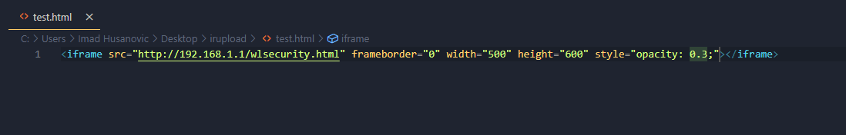
As seen in the image above, I set the opacity to be 0.3 and this is how it looks like:
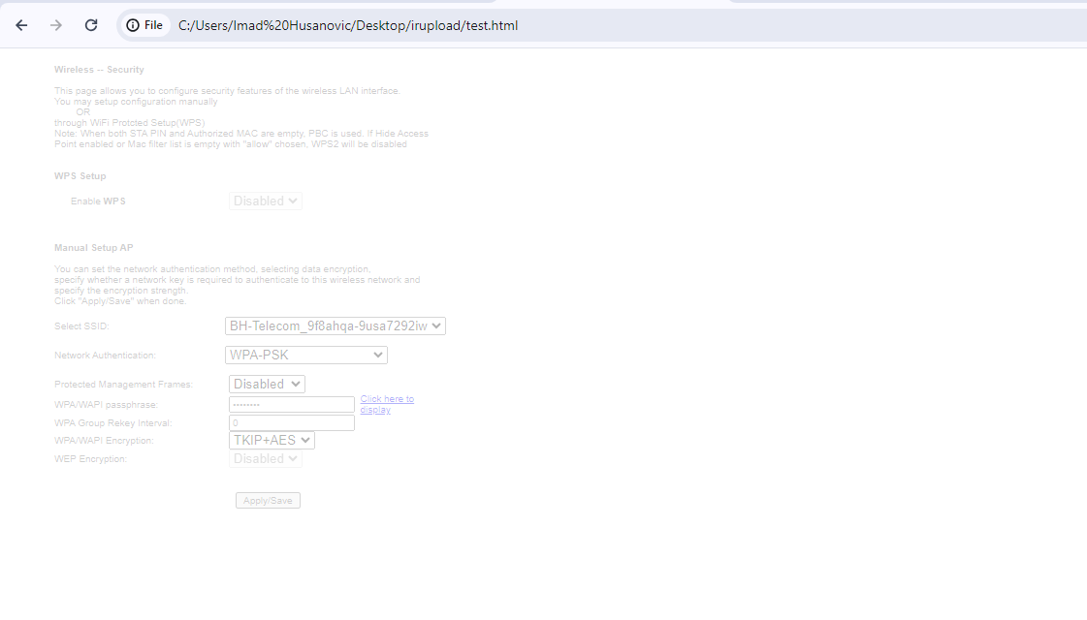
You can barely see it and for your exploit, you would want to set the opacity to 0.001 so that it appears invisible.
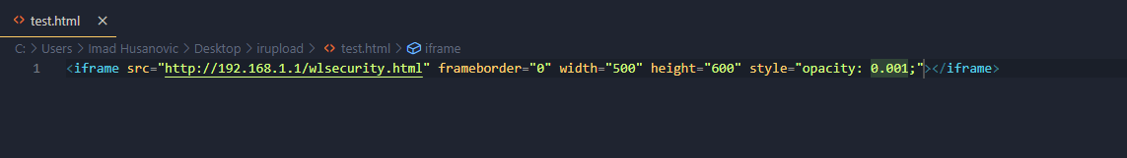
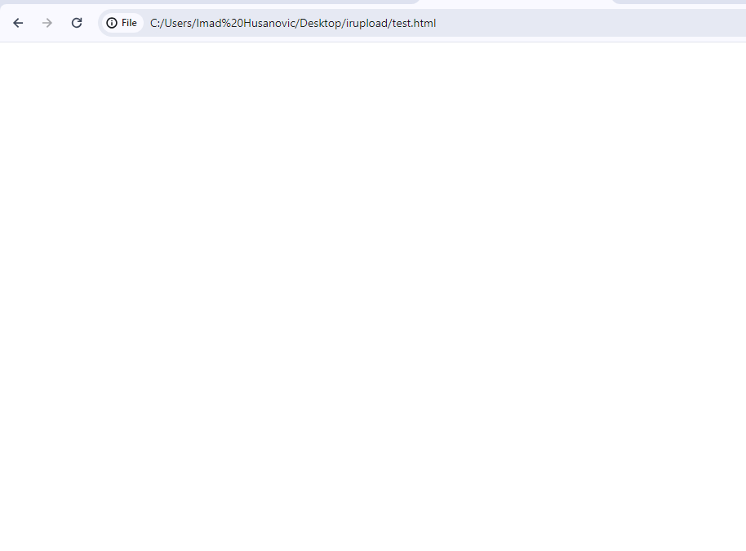
As you can see, the iframe is completely invisible and victim wouldn’t even notice that there is something malicious going on.
I hope this briefly summarizes how Clickjacking or UI Redressing works and I hope you will now change the way you approach a target to find this type of vulnerability.
If you have any questions, you can reach out to me via email ihusanovic3@gmail.com or on Instagram @deadoverflow https://instagram.com/deadoverflow
I will be trying to answer any questions you may have!

IDOR – Insecure Direct Object Reference
Insecure direct object reference is my favorite type of bug to hunt for! I just love to test for these bugs because it’s easy yet, if you find an IDOR, it could be devastating. IDOR can come in in many forms, and that’s why I love it so much, there is always something to test.
Let’s say something about IDOR firstly.
IDOR (Insecure Direct Object Reference) is a type of security vulnerability that occurs when an application exposes sensitive data or functionality by referencing objects directly, without proper authorization checks.
First off let’s find a platform to hunt for a vulnerability. In my case I already have a local platform which is also I use everyday so I understand it a bit better and also, I have multiple accounts on it!
Once I navigated over to the target platform and opened my profile, I will also open Chrome Developer Tools to see what requests are being made (F12, CTRL+SHIFT+I). This way I will know where to hunt for vulnerabilities.
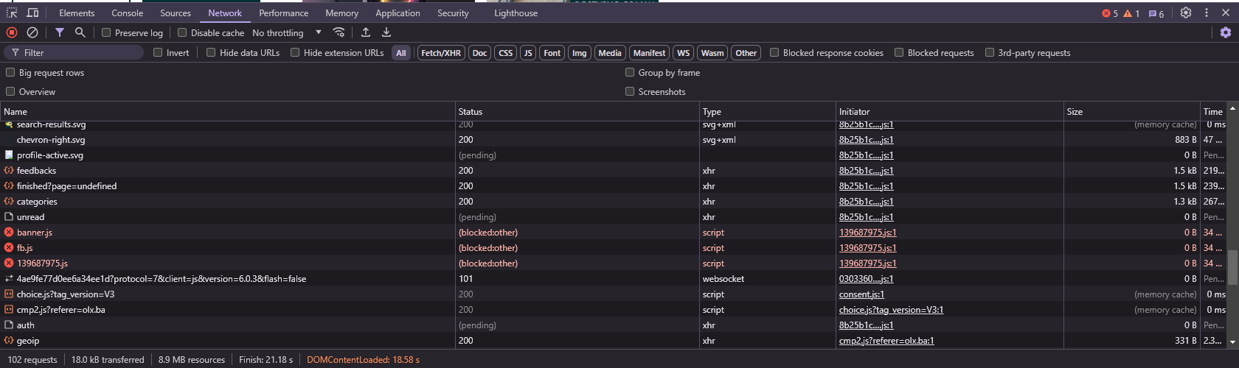
I will turn on the filter to only show Fetch/XHR requests that are being made.
Now we can see what are the requests that are worth looking into when it comes to finding an IDOR.
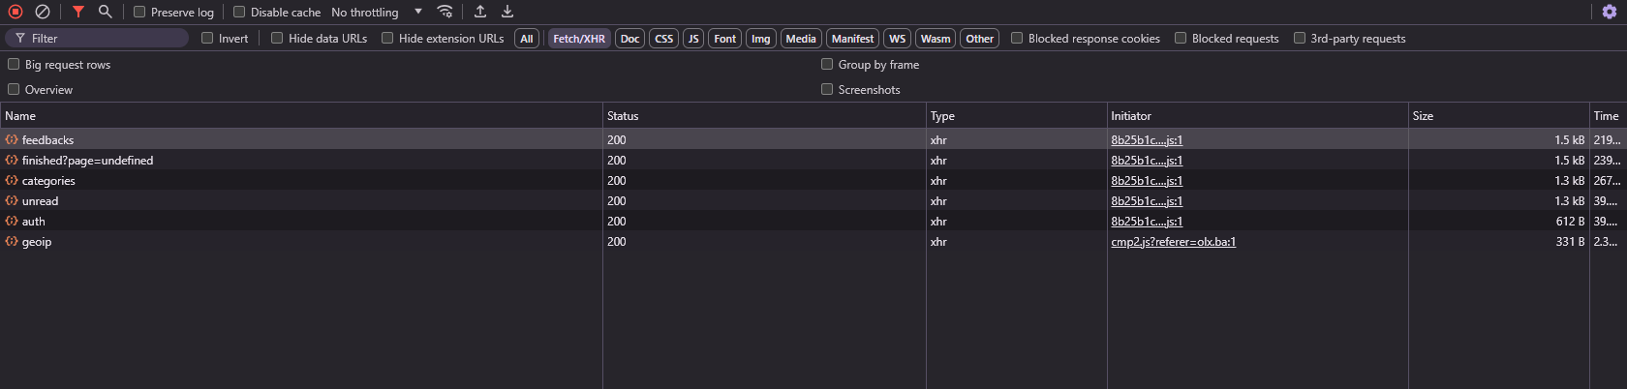
However, these requests don’t load anything specifically interesting, its all available once anyone opens my profile anyways, so let’s move on to the Messages. I will open the messages and again open the Chrome Developer tools and select Fetch/XHR.
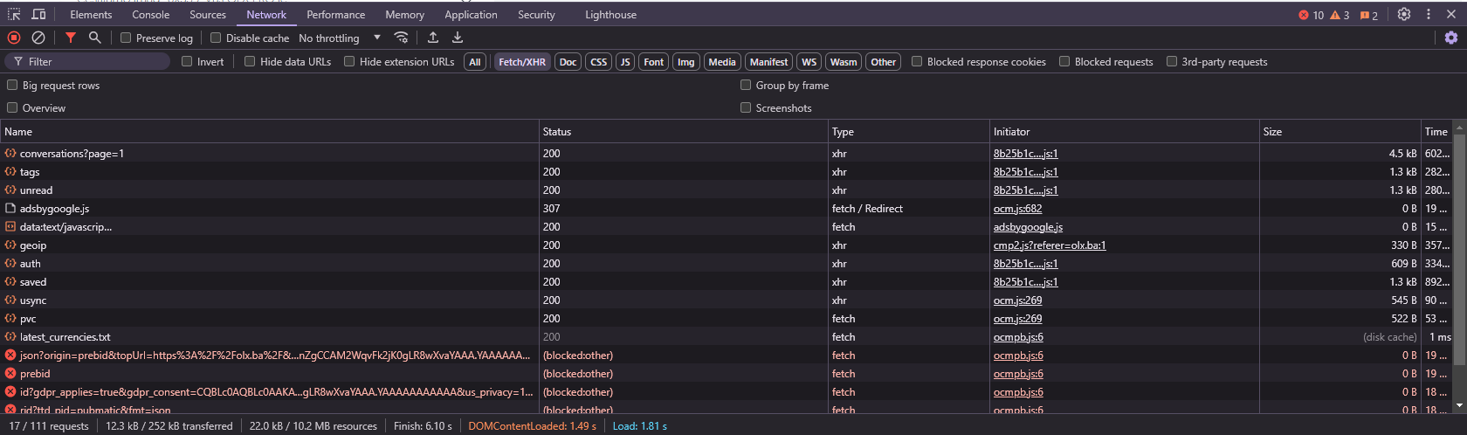
Now here are some requests, however let’s try to do something, for example open a chat.
Before I do that, I will click the clean button (or CTRL + L) to clean any requests that have been made so far so it’s easier for me to understand which HTTP request has loaded the messages once I open a chat.
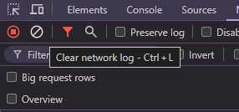
Now when I open a chat, I will see this:
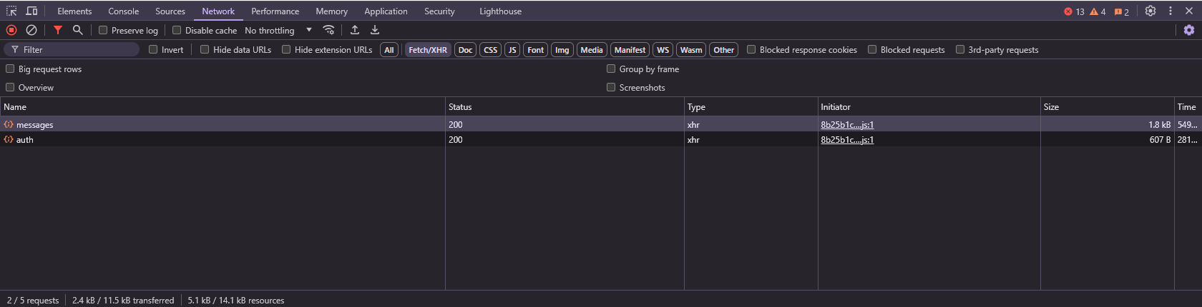
Now to inspect this HTTP request simply click on it.
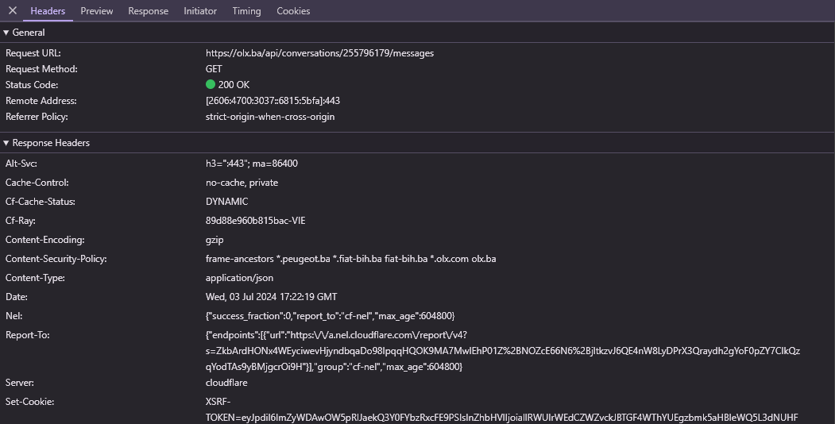
This reveals the ID of the chat from where the messages have been loaded, now let’s try to see if this endpoint is vulnerable to the IDOR. I will right click the request I just opened, then navigate to Copy and finally Copy as Fetch.
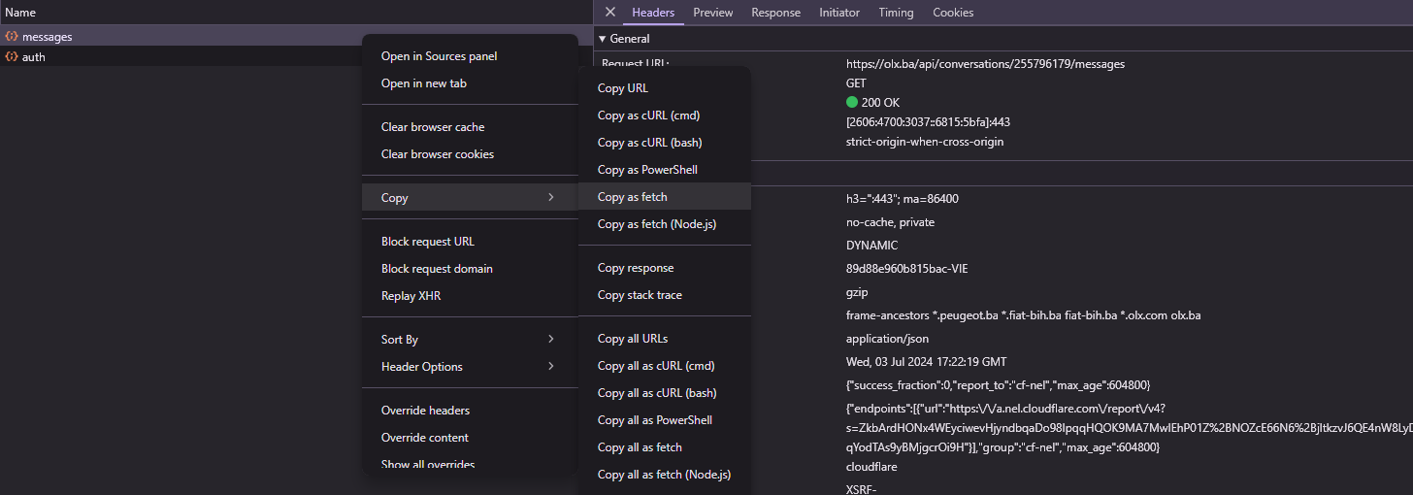
Once I have copied this request as fetch, I will paste it in the console. To open a console you can simply navigate to the console by clicking on the console tab in the top of the Developer Tools.
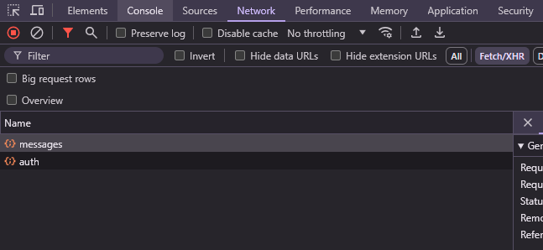
Once you click on console you should see something like this.
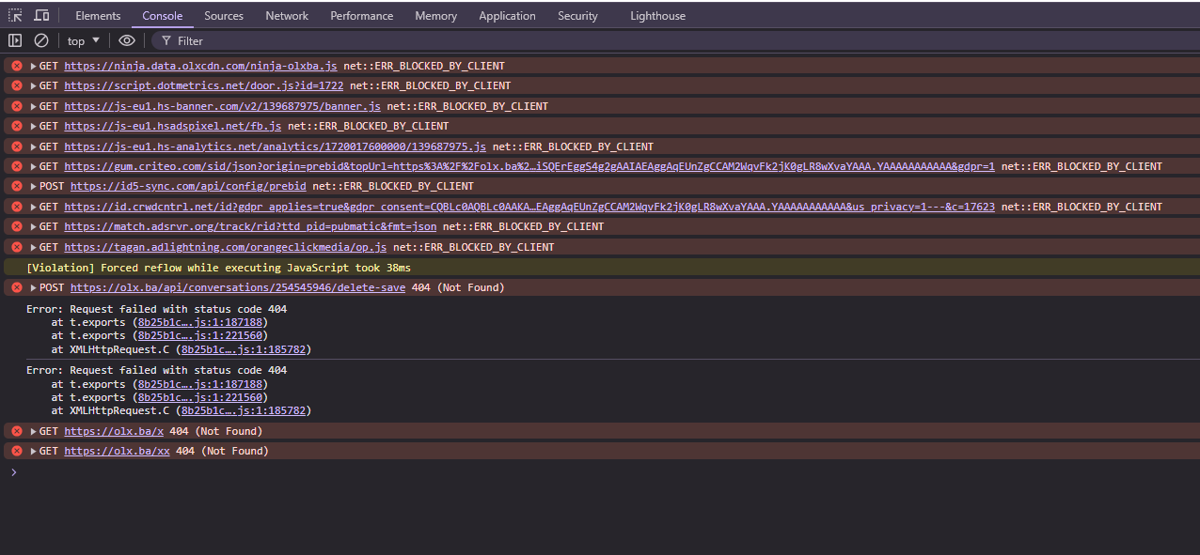
Now paste the code you have just copied in the console.
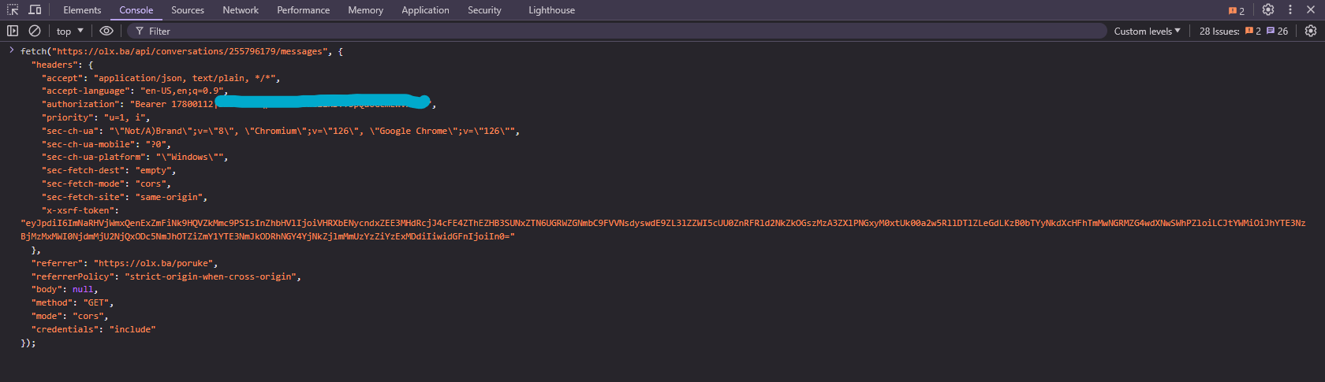
Now let’s try to change the ID of the chat to see if something is going to happen.
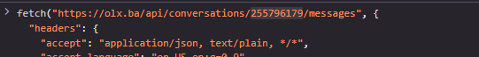
Let’s put a chat here from my other two accounts and see if it gets loaded. You don’t want to put a random value here since in case that it works, you are no longer doing ethical hacking as you just have request to see messages from two users and you are not allowed to do that.
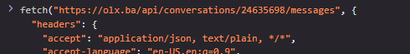
Once I have changed the ID of the chat I am trying to load and I am not a user in this chat, I will hit enter to see what happens.
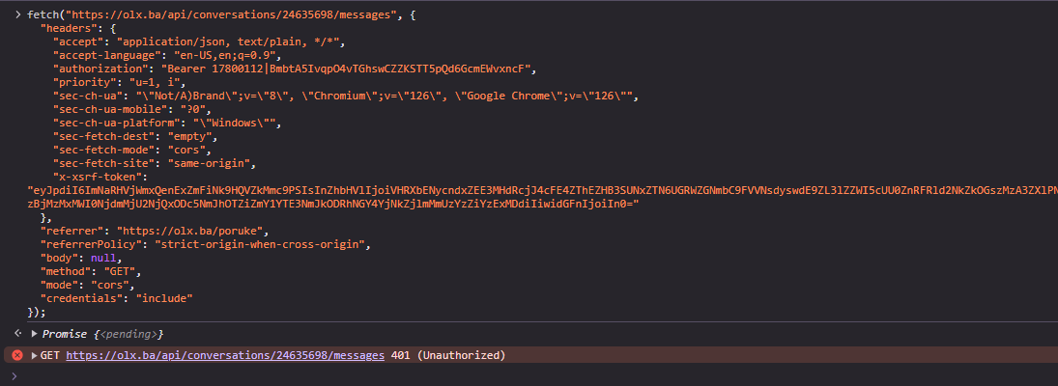
As you can see, the response of this request was 401 meaning that this endpoint is not vulnerable to and IDOR.
However now we can try different things instead. Maybe we can send a message to this chat. To test that, firstly clear out all of the requests made and send a message to a test user. But for this we will use the Burp method. Make sure you have burp up and running now.
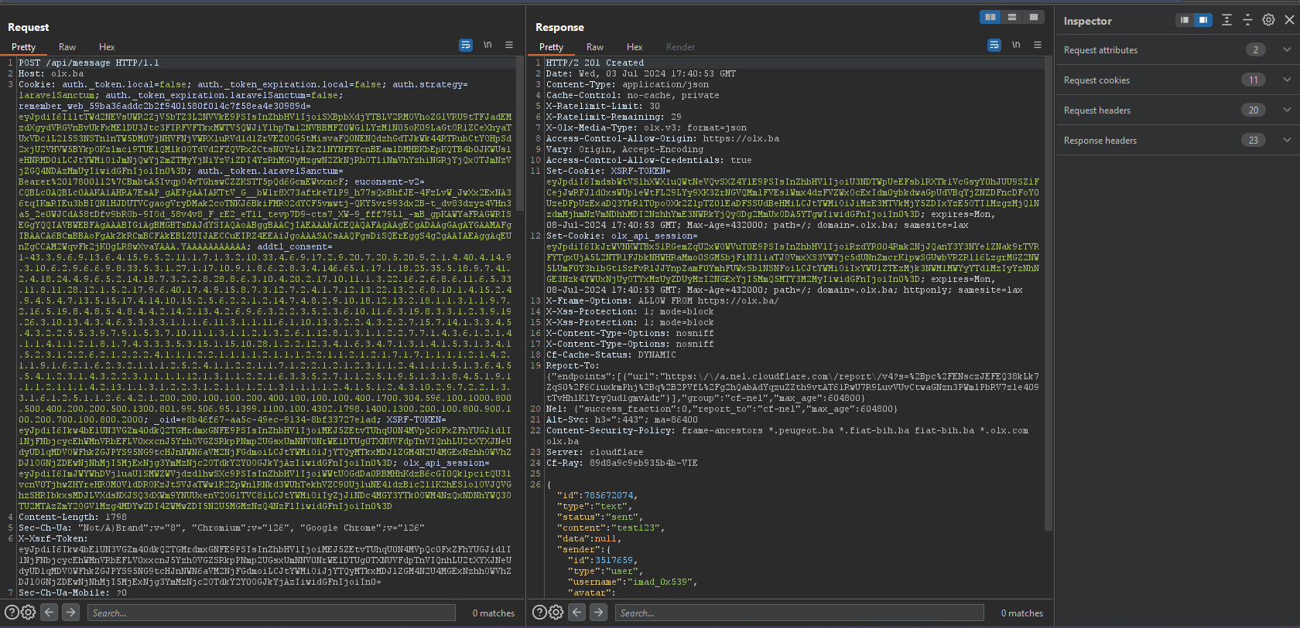

Once I sent a message, I was able to find the exact request which sent the message and now we can send this request to the repeater (Right click + Send to repeater) or (CTRL + R).
Now navigate to the repeater tab to edit this request and try to test for IDOR.
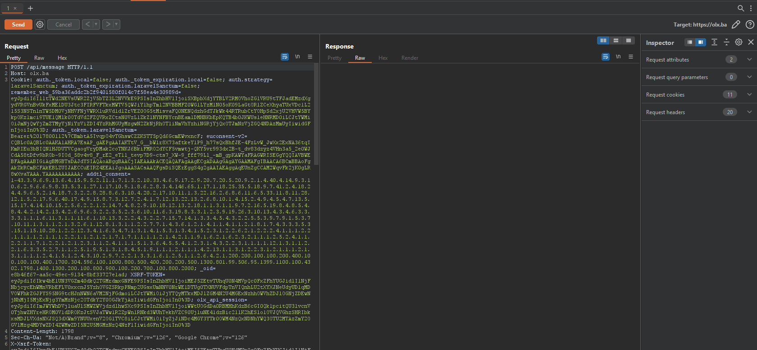
I can scroll down to find the request body and see what I can change to test for IDOR.
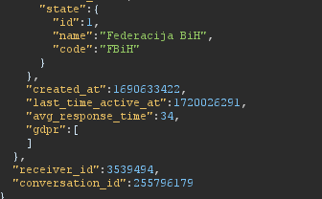
There is a lot of stuff, however I will try to patch the conversation_id to a different chat and try to send the request.
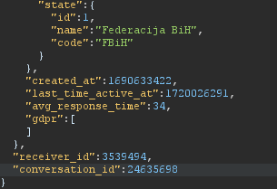
Once I have changed that, I will click on the “Send” button and see what happens.
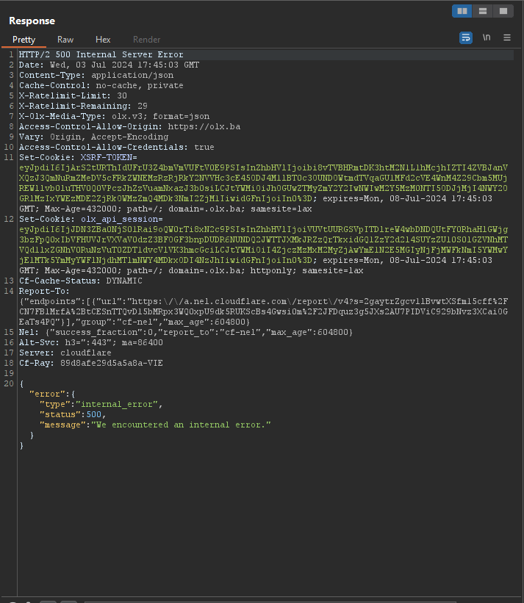
And I got 500, meaning this message was not able to be sent. You now understand that basically IDOR is just playing with ID’s hoping something works.
This is how IDOR works and you can check out some more information on how to test it inside of the videos I have supplied in the Video Course folder. I hope you can understand now how to hunt for IDOR and this may be the break through that you needed.
If you have any questions, you can reach out to me via email ihusanovic3@gmail.com or on Instagram @deadoverflow https://instagram.com/deadoverflow
I will be trying to answer any questions you may have!

WebSocket vulnerabilities
WebSocket vulnerabilities are yet another gold mine since they are very easy to miss and mostly people are not familiar with them. They are somewhat similar to logic bugs however they can be much more devastating if there is a WebSocket vulnerability present.
First of all, I will be using a PortSwigger’s lab to showcase how you can hunt for this vulnerability in the wild so let’s get started!

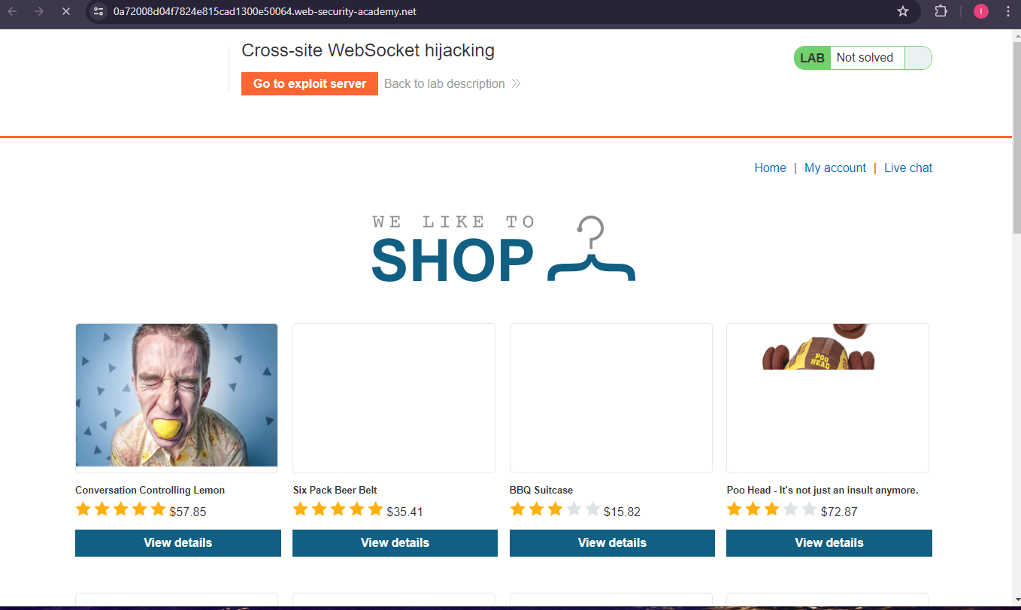
Once I have loaded the lab, I will open chrome developer tools and inspect if the website is making any WS connections.
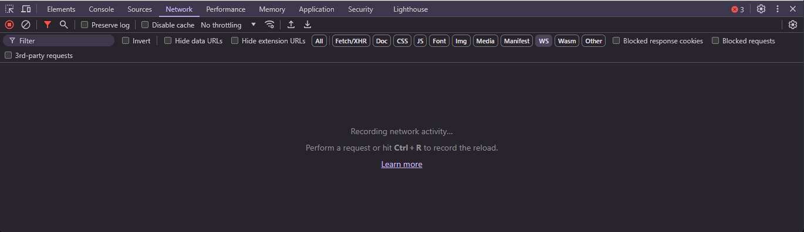
Now I will just refresh the page and we can see a new WS connection pop up.\
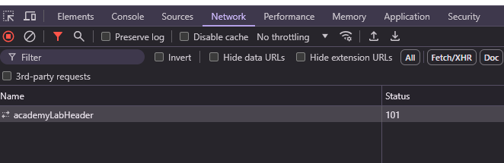
But this is not the WS connection we wanted to let’s head over to the live chat to see if there is something happening there.
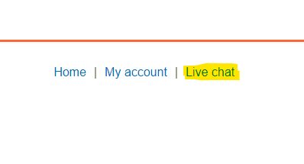
Now once I navigate to the Live Chat, I can see a new WS connection being made. So, let’s inspect it
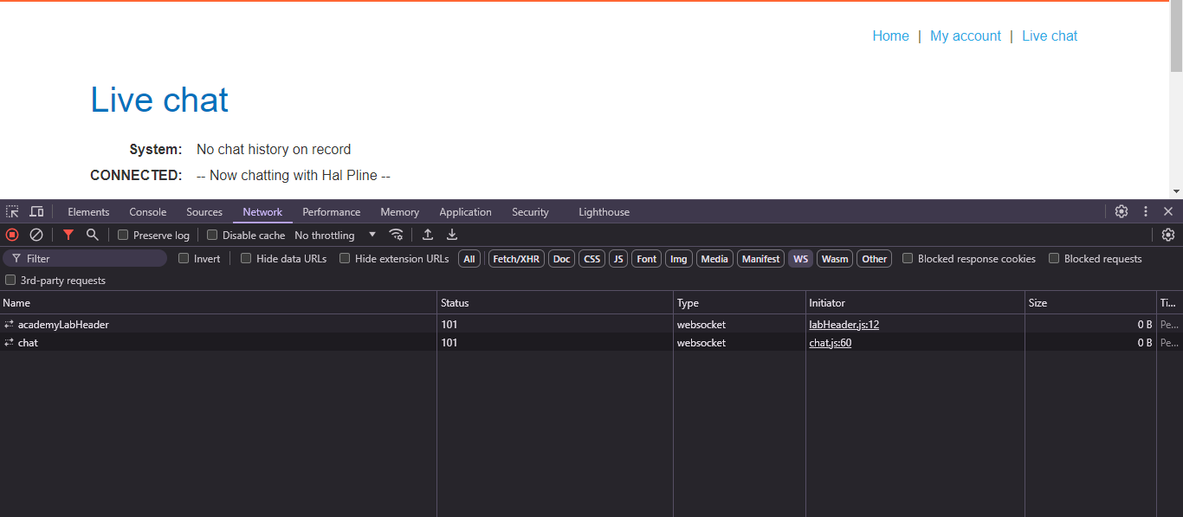
You can click on the connection to see more details.
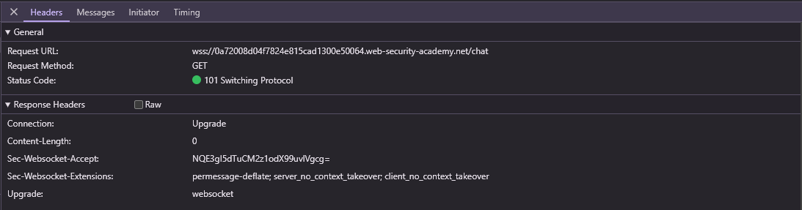
You can now click on Messages tab and see what messages are being sent and received.
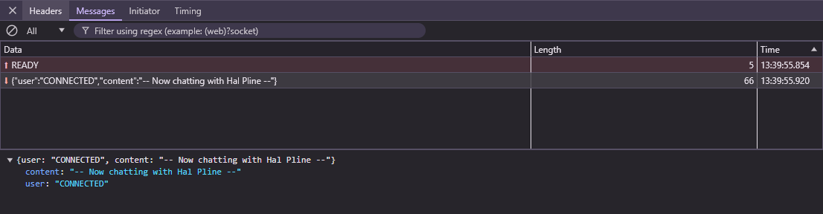
Now we can try to craft something like CSRF exploit. We can maybe try to make a new website which connects to the WS and gets the messages. If there is no protection against Cross Site WS hijack, then we can send a link to a victim and read its messages.
You can ask Chat GPT to craft you a malicious JS code that would connect to ws and read everything in the response.
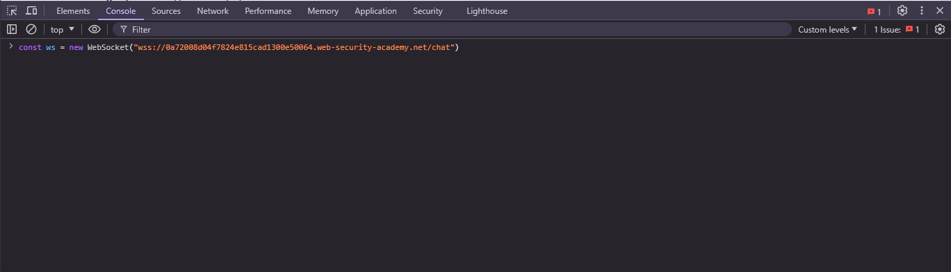
This is a way to connect to a websocket in JS so lets press enter and see what happens.
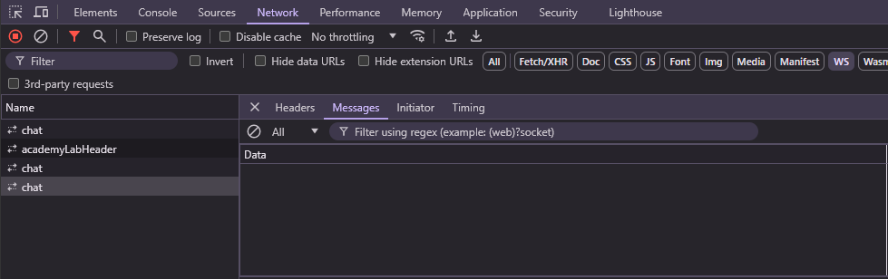
As you can see, we can connect to a WS server so let’s try to send something, the client sends “READY” string so let’s do that too.
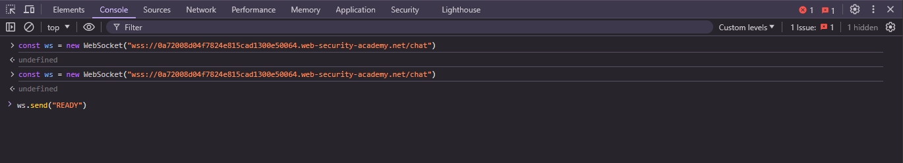
To send something, we can use ws.send() function.
Hello, world!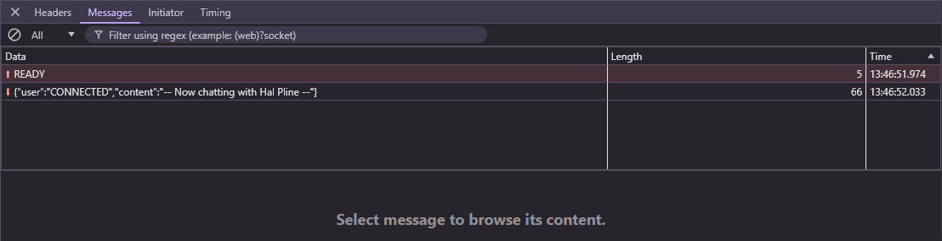
As you can see, it works so let’s now try to craft an exploit and exfiltrate all of the victim messages to potentially see something confidential.
So this is the exploit I came up with, you can use ChatGPT or if you know JavaScript you can even build your own exploit!
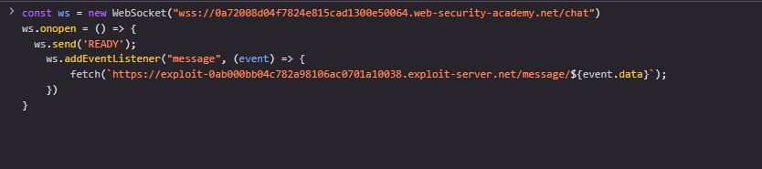
Now we must store this on the exploit server.
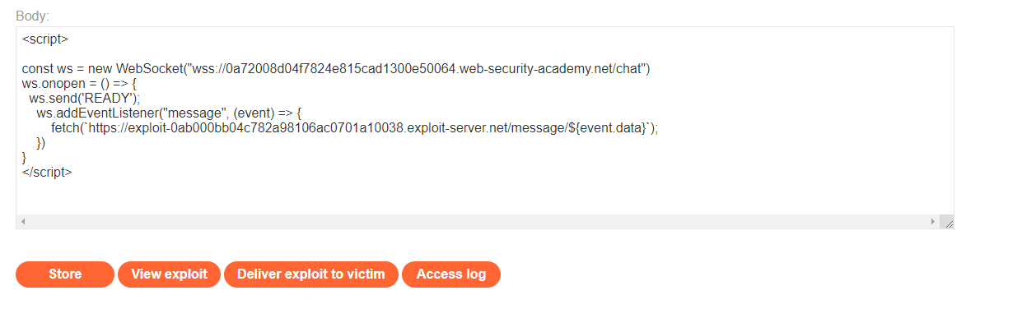
Now I will click store and then press “Deliver exploit to victim”. If the exploit is successful, I should see WS messages once I click the “Access log” button.
Now the moment of truth, I have pressed the deliver exploit to victim button and now let’s see if it has worked.
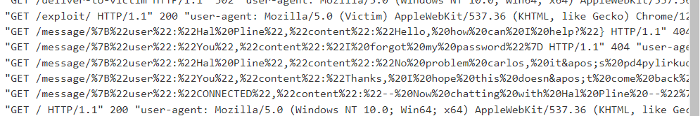
There in the logs, we can see a bunch of URLS containing encoded JSON objects and those are the messages from the victim’s chat. So, lets see what each of these messages contain using URL decoder.
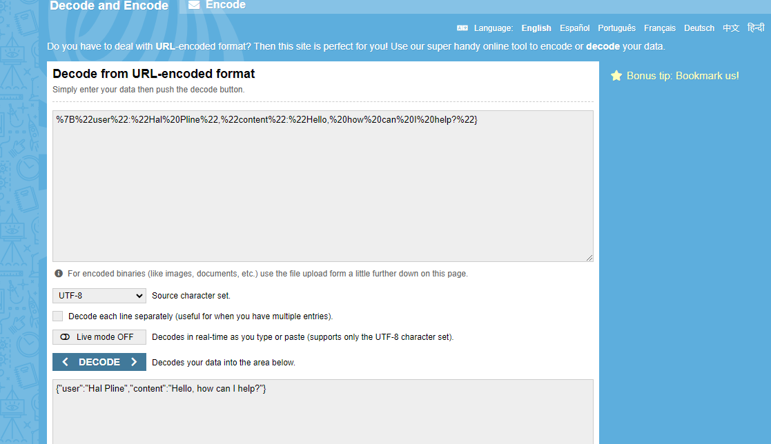
First message doesn’t contain much information so let’s move on to the second one.
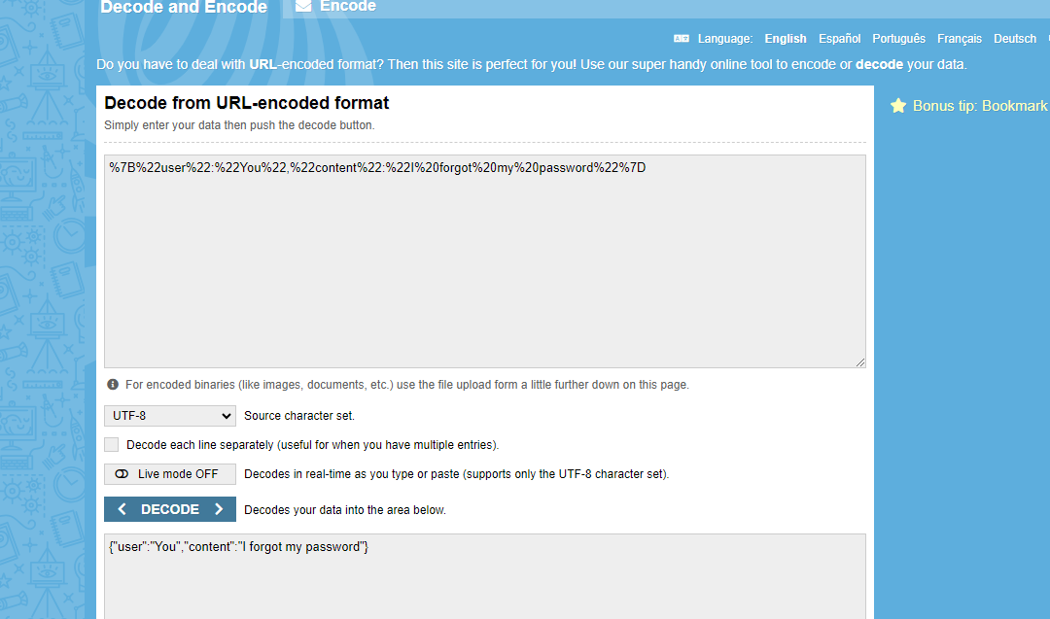
Now it gets interesting, our victim said to the other user that he or she forgot their password. Let’s see what next message has to reveal.
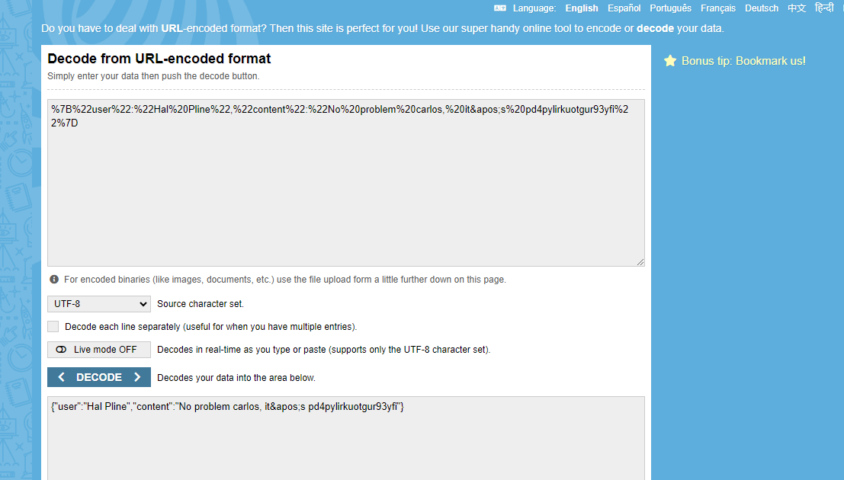
Now we know what the password from our victim is and what their username is so let’s try to login to their account.
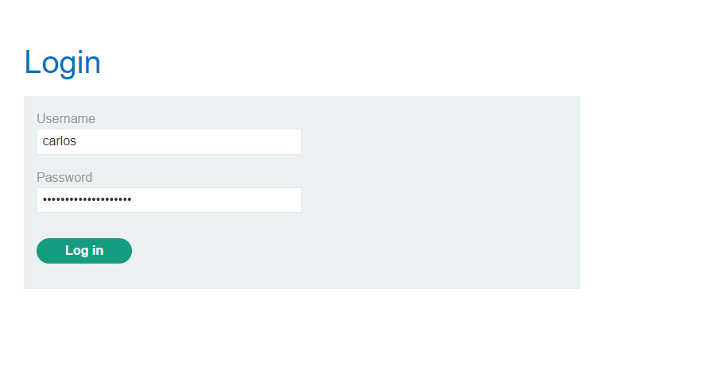
Now let’s click login to see what happens.
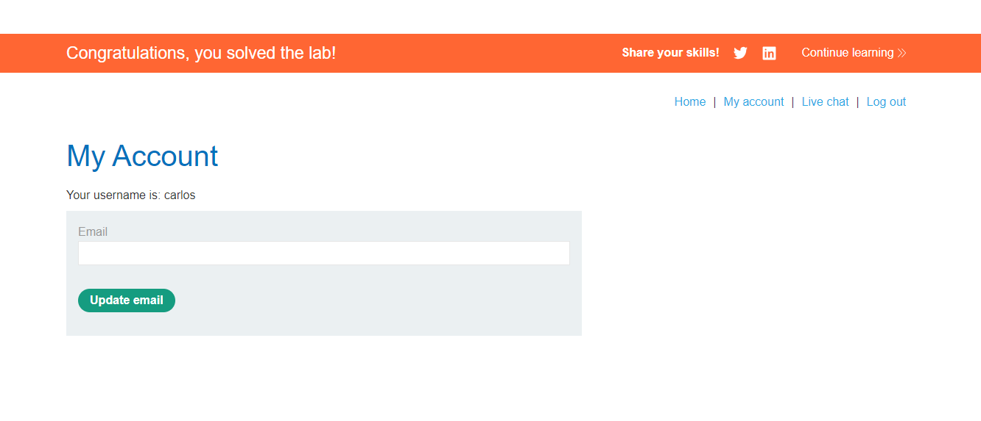
I was able to exploit the WS cross site hijacking vulnerability to exfiltrate the user’s message which contained their password so I was able to login into their account and solve this lab.
If you have any questions, you can reach out to me via email ihusanovic3@gmail.com or on Instagram @deadoverflow https://instagram.com/deadoverflow
I will be trying to answer any questions you may have!

